LARGE ANTIQUE ADVERTISING
& MEMORIABILIA AUCTION
SUNDAY NOV. 21 10:00 A.M.!
DON & LINDA EBERSOLE
JANE ADDAMS COMMUNITY CENTER
430 Washington St., Cedarville, IL 61013
CHICAGO UNION STOCKYARDS & ADVERTISING ITEMS – MISC: 180 Stockyards Postcards 1880-1960; Livestock Commission Co. Pencils & Paper Advert; 50+ Bullet Pencils; 3 International Livestock Pennants 1940-41; 30+ Shadow Box Adver. Thermometers; 1901 Ogle & Stephenson Co. Breeders Books; 1941, 48, 58 Livestock Show Catalogs; National Provision Magazines; Rare Commission Co. Trade Cards; 1935 Exhibitor Pass, Chicago; 1900’s Assort. Livestock Bills of Sale & Invoices; 20+ Advertising Yardsticks; Advertising Canes; 75+ Old Calendars 1900’s-1965, local towns; Hazelhurst Elevator Items; Polo Adver.; Ash Trays;1907 Poland China Registry; 1901 Commission Firm Books; Elsie & Elmer Post Cards; Stockyards Paper Wts; Jack’s knife Shop Items; Paper Feed Bags-Dakota, German Valley, etc; Stockyards View Cards; Mt. Carroll Adver. Items; 6 Tin & Cardboard Barns; Cardboard Toy Buildings; Ideal Salt Crock; Dairy Cattle Congress; Brookville Sale Barn; Several 1900’s Prairie Farmer; 1912 Farmer Weekly; Seed Corn Items; Seed Corn Bags; Miniature Kitchen Items; 1950 Kent Feed Lunch Box; Old Beef Pedigree Cards; Kids Games; Seed Corn Books; John Wayne Arizona Hereford Cattle Auction Book, Feb. 8, 1930; 500 Assort. Advert. Pencils; WLS Items; Old Magazines; IHC Advertising; Milk Bottles; Arcade Coffee Grinder; 1971 Chicago Tribune Diary “Union Stockyards”; Showcases; Plus much more paper items. Many local &
RARE items!
SPECIAL ITEMS: 1920’s 16-pc. Spice Set w/ Salt Crock & Wood Rack; 50+ Pcs. Gray Graniteware;
5 Blue & White Graniteware; 10 Rare Chicken Waterers –Redwing, Macomb, Buttermilk, etc; Assort. Stone wear, Crocks & Vinegar Jugs Advertising; 30+ Lard Adver. Tins; 1870 Wood Grain Cradle.
CONSIGNMENTS FROM MONROE, WI COLLECTOR: 50+ Oil Advertising Cans; 10+ Beer Signs & Lights; 50+ Kitchen Tins incl. Rawleigh, McNess, Maxwell House, etc; Adver. Flyswatters; Seed Corn Signs; 5+ Old Adver. Tin Signs; Beer Trays; Country Store Items.
Auction held inside w/ seating, Lunch & social distancing. MASKS REQUIRED AGAIN PER MANDATE BY STATE GOVERNOR FOR INDOOR ACTIVITIES.
Terms: Cash or check w/ picture ID. Preview 1 hr. prior to sale time.
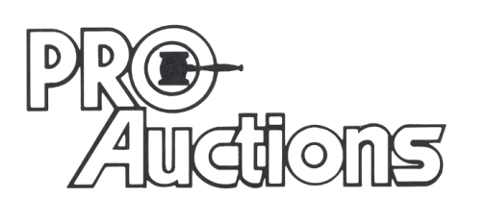
, LLC
Check website for lots of pictures.
www.Proauctionsllc.com
RICK GARNHART, AUCTIONEER
IL Lic: 440000901
German Valley, IL 815-238-3044

