TOY AUCTION
SUNDAY OCT. 10 10:00 A.M.!
Donald Bouma Collection, Franklin Grove, IL
JANE ADDAMS COMMUNITY CENTER
430 Washington St., Cedarville, IL 61013
FARM TOYS & TRUCKS: 250 Pcs. J.D. Toys, 1/6 & 1/64; Sales & Manuals for JD Machinery; JD Books; Tru Scale Machiney; Rare: 7 Handmade 1/16 Wood Tractors, Trucks, Bull Dozer; Assort. Show Tractors; JD Patio Set Lawn & Garden; Museum Tractors; Farm Progress Tractors; Tonka Aerial Ladder Truck; Smith/Miller GMC; Structo: Car Hauler w/ Cars, Cement Truck, Tilt Cab Kroehler Semi; L.S. Semi; Nylint Napa; Napa 25 Anniv. Trucks; 75 Beyer Horse Collection, NIB; JD 5020 w/ old box; Forreston FFA Oliver Tractors; Air Jack Hammer Drill; Lg. Fire Truck; Hyd. Heavy Dump Truck; Farm Set w/ animals; Road Grader, new; Lg. Track Loader; Husky Crane; Steam Shovel, new; Husky Mobile Crane Shovel; Elec. Cannon (very rare color); Earth Mover Scraper; Lg. Pumpkin Wreaker; Tootsie toy Bulldozer, (unmarked, rare); Ertl IH Pay Hauler; Code 3 Diecast Fire Dept Van; 30+ HO Scale Locomotives; 50+ HO Scale Rolling Stock Passenger & Freight Cars; 30+ Unbuilt Models; 300+ 1/64 Tractors & Implements, all colors.
Note: Many NIB.
Auction held inside w/ seating, Lunch & social distancing. MASKS REQUIRED AGAIN PER MANDATE BY STATE GOVERNOR FOR INDOOR ACTIVITIES.
Terms: Cash or check w/ picture ID.
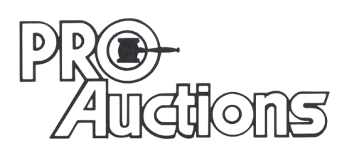
, LLC
Check website for pictures and more listings.
www.Proauctionsllc.com
RICK GARNHART, AUCTIONEER
IL Lic: 440000901
German Valley, IL 815-238-3044

