REAL ESTATE & HOUSHOLD AUCTION
SAT. SEPT. 18 10:00 A.M.
(RAIN DATE: MON. SEPT. 20) REAL ESTATE: 1:00 P.M.
MARIAN JANSSEN, OWNER
Property Location: 602 N. Walnut, Forreston, IL; North edge of town on Rt. 26.

OLDER 2-STORY HOME W/ 3 Bedrooms: Fireplace, Recreation Rm.,
3-Stall Garage w/ attached workshop . Outbuilding: 20’ x 40’ Pole Shed. Includes 2 extra lots/acreage.
Terms on Real Estate: Cash 10% down. Balance due in 30 days. Call Auctioneer for more information.
ANTIQUES-HOUSEHOLD- COLLECTIBLES: Carved Oak Chair; Cane bottom Chair; Sm Oak Curio Cupboard; 2 Pine Tables; Pine Wash Stand; Monmouth Cookie Jar; 1900’s Baby Bed; Pine High Chair; 1920’s Doll Wicker Stroller; Pitcher & Bowl Set; Phonograph Chest; 2 Pine Chest Drawers; Emerson TV; Love Seat; Recliner; Frigidaire Refrig/Freezer; Maytag Wash Machine; Hotpoint elec. Dryer; 1960’s Kimball Piano w/ bench; Bookcases; 100+ 1940-50 Work Basket Books; Fancywork; Pots & Pans; Full sz. Bed w/ 2 chests; 2 Wicker Chairs. SPECIAL ITEMS: 100+ pcs. Of Local Advertising (Forreston, Baileyville, Shannon, etc):Calendars, Canes, Yardsticks, Thermometers, Cheese Boxes, Nail Aprons; 500+ Adver. Pens & Pencils; Old Advert. Boxes; 1900’s Cardboard Farm Set; Daisy Tin Barn; Post Magazines; Children’s Books; Wood Bowling Game; 2 Coaster Wagons; Lg. Toy Box. TOOLS-LAWN & GARDEN: 100,000 btu Heater; 35,000 btu Heater; Wagon full sm. Tools (sockets, wrenches, etc); 2 Bench Grinders; DeWalt Saw; Jonsrud Saw; Power Washer; Table Saw; Girls Bike; Sleds; Fishing Poles; Lawn & Garden Hand Tools; Old Traps; 1900’s Garden Cultivators; Picnic Table; Porch Swing; Lawn Chief 20” Garden Tiller, 5 hp; 6 hp Push Mower; Troy Bilt 24” – 5 ½ hp Snow Blower; Nice Simplicity 20 hp Lawn Tractor w/ 38” deck, hydro, only 955 hrs; 5’-3 pt. Blade; 2 older Boats & Trailers; Plus much more odds & ends.
Terms on Personal Property: Cash or check w/ picture ID. Lunch Stand & Port-a-Pot on grounds.

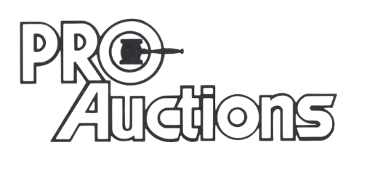Check website for pictures & more info. www.Proauctionsllc.com
, LLC
RICK GARNHART, AUCTIONEER 815-238-3044
German Valley, IL License #: 440000901

