HUGE J.D. TOY AUCTION
SUNDAY AUG. 8, 2021 10:00 A.M.!
Donald Bouma Collection, Franklin Grove, IL
JANE ADDAMS COMMUNITY CENTER
430 Washington St., Cedarville, IL 61013
250+ TOYS: 100% NIB, 40 YR. COLLECTION:
First 25 Precision JD Tractors & Implements; First 25 JD Bank Collection; 10 full sets JD Key Series; Pewter JD Tractors; JD HO Train Sets; 50+ Plastic Truck, Trailer, Tractor Model Kits;
15+ Farm Country Building Sets; Cockshutt NFTA Museum Set; JD #6 PTO Corn Sheller, custom; Plus much more. Also other brands Farm Tractors. Auction held inside w/ seating & social distancing.
Terms: Cash or check w/ picture ID.

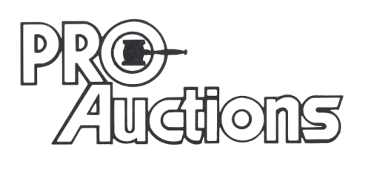Check website for pictures and more listings.
, LLC
Proauctionsllc.com
RICK GARNHART, AUCTIONEER
IL Lic: 440000901
German Valley, IL 815-238-3044

