HUGE J.D. TOY AUCTION
SUNDAY AUG. 8, 2021 10:00 A.M.!
Donald Bouma Collection, Franklin Grove, IL
JANE ADDAMS COMMUNITY CENTER
430 Washington St., Cedarville, IL 61013
500+ TOYS: 100% NIB, 40 YR. COLLECTION:
First 25 Precision JD Tractors & Implements; First 25 JD Bank Collection; 10 full sets JD Key Series; Pewter JD Tractors; JD HO Train Sets; N-Scale Train Sets; 50+ Plastic Truck, Trailer, Tractor Model Kits; 75+ Farm Country Building Sets; Cockshutt NFTA Museum Set; JD #6 PTO Corn Sheller, custom; Waterloo Tractor Works Set; Chrome Dealer Sets; JD OPOLY Games;
JD 8200 Track; MF Tractor AMT Kit NIB; 10+ Historical JD Sets; Radio Control Tractor; Joal; CAT; AC; MF; 50+ 1/64 Semi Trucks; Pewter Tractors; 3-6-7000 Kits; 4-860 MF Combines, all different; CIH Precision Sets; 1950-60 JD Tractors, Combines, Plows Wagons, etc; Ford Tractors & Imp; Oliver; White; Kinzie, Plus 100’s more to be unpacked.
Auction held inside w/ seating & social distancing. Masks encouraged.
Terms: Cash or check w/ picture ID.

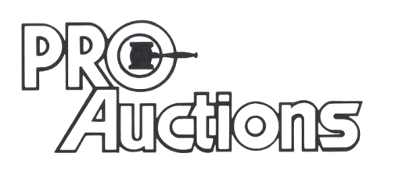Check website for pictures and more listings.
, LLC
www.Proauctionsllc.com
RICK GARNHART, AUCTIONEER
IL Lic: 440000901
German Valley, IL 815-238-3044

