TOY AUCTION
SUNDAY JUNE 13 10:00 A.M.
JANE ADDAMS COMMUNITY CENTER
430 Washington St., Cedarville, IL 61013
STRICT ENFORCEMENT: MUST WEAR A MASK TO ATTEND.
BALANCE OF DON & BETTY LUDWIG ESTATES, FORRESTON, IL: Arcade; Structo; Farm Toys; Plus much more from this Estate. Watch for updates on website. Also a collection of 50+ JD Combines, all scales NIB; 50+ Farm Toys NIB. PHILLIP’S COLLECTION, MONROE, WI: 1950 Wooden Barn w/ Animals; Metal Daisy Barn; Ohio Art Truck; Structo & Nylint Trucks; GI Joe Box & Clothes; Sm. Doll Collection; Marx Horse Collection NIB; Barbie Dolls-1970; Toy Guns & Pistols; Fire Trucks; Car Haulers. PAUL HOFFMAN ESTATE, FREEPORT, IL: Nylint 1/16 Trucks; 1/12th Car Hauler; 50+ Fire Truck Collection; Ambulance Collection; Other Farm Toy. ALLAN WURSTER, ELIZABETH, IL: 30+ Farm Tractors NIB, plus more by sale date. OTHER MONROE COLLECTION: Oliver: Precision 77, S88 Freeport, S77 Forreston, 660 FFA, 1855; JD Utility; JD 630 LP; MH Challenger; Gray Case; Ford 8N, Ford , Jubilee; Ford 7710 FWA; T.S.M; Assorted 1/64IHG Precision Tractor; Farmall Regular,gray; Farmel MV High Crop; Farmall F-20 Red; Farmall F-20 Gray; Vertical Steam Engine w/ box; Midge Toys NIB; All NIB-AC:D-14, 4C; Case: L, VC, DC w/ loader; Fordson; IHC: Cub, MTA, 706, TD340; JD: 40, 4440, 45 Combine, 442 Plow; MH175; MM Twin City; Oliver: 995, GM; 9 Dodge Viper Cars; Plus others.
Terms: Cash or check w/ picture ID. Lunch Stand, Seating & Restrooms available. Seating w/ social distancing observed.

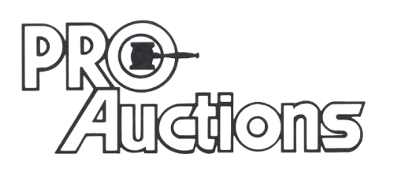Check website for pictures and more information:
, LLC
Proauctionsllc.com
RICK GARNHART, AUCTIONEER
IL Lic: 440000901
German Valley, IL 815-238-3044

