LARGE TOY AUCTION
300+ FARM TOYS
SAT. MARCH 20, 2021 10:00 A.M.
(Inclement Weather Date: Sun. March 21)
JANE ADDAMS COMMUNITY CENTER
430 Washington St., Cedarville, IL 61013
STRICT ENFORCEMENT: MUST WEAR A MASK TO ATTEND. IF YOU PREFER NOT TO TAKE COVID PRECAUTIONS, STAY HOME! SOCIAL DISTANCING, ETC.
DON & BETTY LUDWIG ESTATE, FORRESTON, IL
ARCADE COLLECTION, 75+ pieces Plus Other: Horse drawn Wagon & Fire Truck, Kitchen items, Cars, Bus, Trucks, Animal Bank Collection, 3 Cabs, AC Sand Hauler, Nativity Set, Lion Bank, 8” Bus, Wood Marble Game, Some reproduction cast iron; Structo Cars; NI Pull Picker; Coca-Cola. FARM TOY CONSIGNMENTS & TRUCKS: Assort. 1/16 NIB Tractors; 1/64 IHC Collection, NIB; Steiger 1/32; 20+ 1/64 Toy Semi Collection incl. Land-o-Lakes Semi, Texaco Semi, Allied Semi; 1/18 Trucks & Cars NIB; Fox 3000 Chopper w/ heads; NH TL100 Tractor; NI 350 Spreader; 1/8 Ferguson TE-20; IHC: 5088, 5288, 1456, 886, 1486, 5488, 806, 1206, 660, 460, SM w/ Picker, 966, 1566, 1586, 1256, 606, 706, 400-450; Assort. C-IH 1/16 NIB; Case Tractors; OLIVER: 1950T, 1650, 1850, 2255FPS, 2255 Hille Equip, S88 HC, 588 Picker Tractor, 1750, 77LP; Assort. 1/16 AC, Moline, JD, MF; JD: 6600 Combine, 80 Prestige, A; 1/16 Big Farm Combine; AC 7060; MM 4 Star; NH 7740; 50+ JD COMBINE COLLECTION: 1/64 95, 9500, 9610, CTS11, 9750, 9860, 7720, 9860, 9670, Assort. Farm Show Combines; 1/80 7720 w/ 4 heads, 1/22 9750, 2256, 9880, 9870, 9760, 1/50 Combines; 1/28 Combine, 1/87 Combines; Show Tractors Monroe FFA; IHC PEDALS: 1066 5-Mill Pedal, 1466, 100 hydro Red Power Pedal, C Pedal; Assort. Toy Banks; ABC Book; Sm. Bank Collection; Marbles.
Note: Join us for another offering of great toys, including a large rare collection of Arcade. More to be unpacked!

Terms: Cash or check w/ picture ID. Lunch Stand, Seating & Restrooms available.
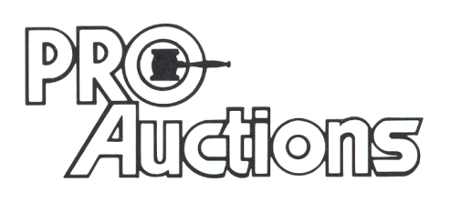Check website for pictures and more information:
, LLC
Proauctionsllc.com
RICK GARNHART, AUCTIONEER
IL Lic: 440000901
German Valley, IL 815-238-3044

