HUGE TOY AUCTION
350+ HIGH QUALITY FARM TOYS
SAT. MARCH 6, 2021 10:00 A.M.
(Inclement Weather Date: SUN. MARCH 7)
JANE ADDAMS COMMUNITY CENTER
430 Washington St., Cedarville, IL 61013
STRICT ENFORCEMENT: MUST WEAR A MASK TO ATTEND. IF YOU PREFER NOT TO TAKE COVID PRECAUTIONS, STAY HOME! SOCIAL DISTANCING, ETC.
2 LG. NORTHERN ILLINOIS COLLECTIONS,MANY NIB
Vernon Johnson Collection, Kirkland, IL: J.D. – 4020 Pedal Tractor, wf, 720, 620, 2510, 3020, 110, 4960, MT, A, 5020, D, B, M, 2640, 7610, 7800, GP Gray, 2011; ARCADE – Ford Tractor, Thrashing Machine, Wagon, Drag, Cook Stove, Fire Engine; IHC – 400, 450, 560, 560 Puller, TD 25, 7 bottom Plow, 4230, 1586, 10-20, F-20; Hubley; MM UTU; MH 44; Ford 8N, 9N; AC G; Oliver 1800; 15+ Tru Scale, made in Rockford, IL – 3-890 Tractors, 3- 560 Tractors, 3- M w/ yellow wheels, 2 Combines, 2 B. Plow, Sickle Mowers, Chopper, Elevator, 460 Custom, Wheel Disc, Auger; Plus many Show Tractors & Other Misc. Farm Toys.
Don Wesemann Collection, Hampshire, IL: OLIVER – 4 different 1965 Oliver Tractors 1800 & 1850, PTO Baler, Motor Baler, 1 R. Shik Picker, Wing Disk, Slik Grain Drill, Rare Wobble Mower; 4 B. Plow, Slik Spreader, Slik Wagon, Barge Box, S-88, OC-12 Crawler, S-77 Precision, OC-3 Crawler, 88 Standard, 990 GMD, Plus more Oliver items; FARMALL- 806 FFA, 560 NF Fast Hitch, 1466 w/ duals, Little Genius Plow, Dearborn Plow & Blade, 606, iHC 22-36, TD24 Plastic Crawler, assort. Plows, 544 custom, 915 Combine; TRU SCALE – 2- 560 NF, yellow Tractor w/open & closed belley, Restored 560, Restored Pull Combine, 3-806 (red, yellow, green), Fox Fire Figurines; Reproduction Adv. Signs; LITERATURE of all types; Plus 50+ Collection of 1/64 Tractors & Implements; Other Misc. to be unpacked.
DON'T MISS THIS OPPORTUNITY! Auction held inside w/ seating & lunch available.
Terms: Sales tax 6.75% now collected on all purchases; new law as o1/1/21.
Exception: Proof of sales tax exemption. Cash or check w/ picture ID.
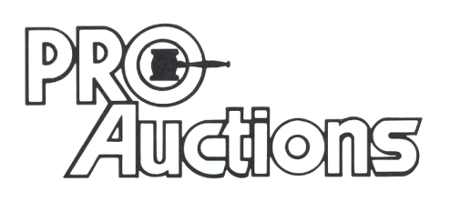 Check website for many great pictures and more information:
, LLC
Proauctionsllc.com
RICK GARNHART, AUCTIONEER
IL Lic: 440000901
German Valley, IL 815-238-3044

