HUGE TOY AUCTION
SAT. FEB 27, 2021 10:00 A.M.
(Inclement Weather Date: SUN. FEB. 28)
LEON & GARNET OBENCHAIN
JANE ADDAMS COMMUNITY CENTER
430 Washington St., Cedarville, IL 61013
STRICT ENFORCEMENT: MUST WEAR A MASK TO ATTEND. IF YOU PREFER NOT TO TAKE COVID PRECAUTIONS, STAY HOME! SOCIAL DISTANCING, ETC.
300+ FARM TOYS, (80% NIB): Big Bud: 1/16, 1/32, 1/64 plus black & gold models; Precision: Case 1470, IH: 4366, 4786, 4300, JD: 8010, 7520 (chrome), 9400, 8020; JD: 8850 Silver, #6 Corn Sheller, Expo Tractors, 110 L&G, 1980 Gold 4440 (175th Anniv.), Yoder 730, Custom 4330, 5 pc. Chrome Set, 720 & G Prestige, 60 Chrome, 4020, Elvis 4010; IH: 403 custom Combine, 560 w/ Picker Precision, 656 Demo, M&SM Precision, 1466 precision, MD w/ loader Precision, TD 24 Crawler; AC: L & Garden, D-17 gold, 185 gold, Custom 2 R. Picker, 440,
D-21; CASE: Yoder 700, Yoder 400, 1170 black Knight, 1200 custom Baler,
580 gold; CIH: STX 450; CIH Train Set; JD & MH HO Train Sets; 50+ Implements & Customs; Many Show Tractors; Many Key & Prestige Tractors; FFA Tractors;
CAT D-7Green; Claus Tractors; Holt 77 Crawler; Graham Bradley; OLIVER: OC-12, 77 Firestone, 77 Antique Power; NI 311 Picker, plastic; Restoration Tractors; Arcade Replicas Tractors; CAT D11R gold; Precision Engineering Ohio; Gold Horse Drawn Plow; Clydesdale Team w/ wagon; Many custom Implements & Show Tractors. All colors & scale.
Note: YOU HAVE SEEN OR HEARD OF LEON'S REMARKABLE COLLECTION. STUDY THE PICTURES on the website: PROAUCTIONSLLC.COM
DON'T MISS THIS OPPORTUNITY! Auction held inside w/ seating & lunch available.
Terms: Sales tax now collected on all purchases; new law as of 1/1/21. Exception: Proof of sales tax exemption. Cash or check w/ picture ID.
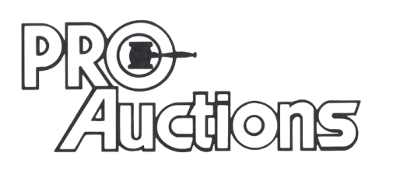Check website for pictures and more information:
, LLC
RICK GARNHART, AUCTIONEER
IL Lic: 440000901
German Valley, IL 815-238-3044

