HUGE FARM TOY AUCTION
SUNDAY SEPT. 20 10:00 A.M.
LEON & GARNET OBENCHAIN COLLECTION
JANE ADDAMS COMMUNITY CENTER
430 Washington St., Cedarville, IL 61013
Please observe physical distancing. MUST WEAR A MASK TO RECEIVE BIDDERS CARD!!
350+ FARM TOY & CONSTRUCTION TOYS, 95% NIB
PEDAL TRACTORS: Ford 7740 wf, JD 7410 wf, C-IHC 7130 wf; AC 8765 wf.
FARM TOYS: IHC TD25 Crawler; Case Steam Engine; IHC 82 Combine; NH S-66 Haybaler; 50th Anniv. Farmall 400 w/ 4 r. Cultivator; JD #1 & CIH #1 Precision Construction; IHC Red Power Roundup; Farmall M w/ mtd. Picker; MM w/ 3 B. Plow; Steiger 325; JD 200 Picker; Sugar Cane Harvestor; Claus Jaguar; JD 45 Prestige Combine; JD 9750 Combine; JD Prec. 544 #2; MH 44 Precision; Ford 8N Precision; Iowa FFA Oliver X0121; Oliver S77 Precision; Yoder 700 Diesel, plastic; Ford 5000 Precision; TD25 Crawler w/ sheepfoot; Case 1570 Spirit; Ferguson/Ford Precision; Silver King; Challenger; NI (C&R) Custom Picker; Case 930 Precision; Cockshutt 20 & 560; Steiger-Coop Bear Cat II; NH 8260; Claus Lexion 480 Combine: JD: A, 4020, 4000, 720, B, 730, 3010, 630, 8020, 70, B; JD 494 Planter; JD 2010 Crawler; Oliver OC-3; Sugar Valley & Ontario Tractors; Oliver-Kansas Special; Plus much more special & custom show tractors & Implements. TRUCKS-CARS-MISC: Miller; Flying J; Mack, Nylint; Beer Trucks; Peterbilt; Pabst; 1st Gear-40+ pcs; Texaco; Horse drawn Wagon; Franklin Mint; Structo.
Note: This is 4th auction in a series of high quality and hard to find Farm Toys-BEST OFFERING YET! Dispersal of 40+ year collection. Many items not listed. Terms: Cash or check w/ picture ID. Seating, Restrooms & Lunch available.
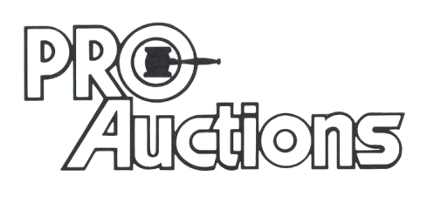Check website for pictures and more information: Proauctionsllc.com and Auctionzip.com
, LLC
Rick Garnhart, Auctioneer
German Valley, IL 815-238-3044 IL Lic: #440000901

