HUGE TOY AUCTION
SUNDAY AUGUST 9 10:00 A.M.
LEON & GARNET OBENCHAIN, 2ND OF 4 AUCTIONS!
JANE ADDAMS COMMUNITY CENTER
430 Washington St., Cedarville, IL 61013
Please observe physical distancing. MUST WEAR A MASK TO RECEIVE BIDDERS CARD!!
500+ FARM & CONSTRUCTION TOYS, MANY NIB
PEDAL TRACTORS: JD 8530 w/ wts & Duals; JD 4020; Spirit of M.M.; JD Service Pedal Car; JD A.
FARM TOYS: Big Buds; Tonka State Highway Set, repaint; Auburn Rubber; Highway Drag line Set; Versatile 9822 4x4; 20+ 1/16 Older Semi Trucks; 15+ Other 4x4 Farm Tractors; 75+ Lg. Assort. 1/64 Tractors & Implements; Case Magnum 8950; Hart-Parr #3; White 4210 Field Boss; Ford T9060, dealer; Kubota Tractor & Wagon Set; Wards Puller; Steiger 535; JD Threshing Machine; Case 1455 XL; FIAT NFTS Tractor; Blue Tonka Truck & Other Tonka Trucks; Versatile 1156 w/ box; CAT 992G; JD 5020; JD 550 Mulchmaster; Repaint Flatbed Toy Truck; Tonka Hi-Way Dept. Low Boy; Versatile Semi; Older Semi Trucks; INT 1994 Farm Show; IBP Semi; TW15 Ford 4x4; JD 40 Ford 4x4; 1996 JD 8870-4x4; Ford Versatile 846, 4x4; IHC 2644; Case 4994, 4x4; IHGC Custom w/ loader; IHC 3588, 4x4; Older JD Disc, gear; Older JD 70 w/ loader; IHC 4230 w/ loader; Plus other Farm Toys still in boxes. Lg. assort. to be unpacked.
NOTE: AUCTION TO BE HELD IN GYM W/ AIR COND. SEATING & RESTROOMS AVAILABLE.
Terms: Cash or check w/ picture ID.
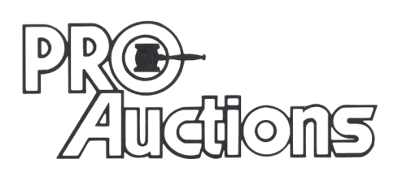Check website for pictures and more information: Proauctionsllc.com
, LLC
RICK GARNHART, AUCTIONEER
IL Lic: 440000901 German Valley, IL 815-238-3044

