LARGE TOY AUCTION
ARCADE-STRUCTO-NYLINT-FARM TOYS-OLIVER
SUNDAY AUG. 23, 2020 10:00 A.M.!
Jane Addams Community Center
430 Washington St., Cedarville, IL 61013
Please observe physical distancing. MUST WEAR A MASK TO RECEIVE BIDDERS CARD!!
JERRY & JUDY PRASSE COLLECTION - ARCADE: Oliver 70 (red), 2 B. Plow, 2 Section Harrow, 2 R. Planter, Wagon, 1/16 Oliver 70, Fordson; NI: Uni System (orange) Combine,
Uni System (gray) Ear Corn; Gleaner Combine w/ 2 heads; SLIK: 77 Oliver, Oliver Grain Drill, Grain Master Combine; OLIVER: Engine Baler, 1850, Wagon, 70 on steel, 88-Freeport Show, 770, 990-Forreston, Crawler; MM-J; 2-JD A Tractors; 2 Ford 6000 Tractors w/ 3 pt; JD A Anniversary; MM Truck Bank; JD 4255 FWA Prestige Tractor; 1/8th JD 1939-D Tractor; R.C. Seahawk Boat NIB; STRUCTO: Dump Truck, 66 Fuel Truck, Plastic Cars, Freeport Motor Express, 1940 Flat Bed, Steam Shovel, Army Troop Truck, Catalog, 50 Assort. Structo Trucks & Trailers; Ford Pickup; Muscle Cars; Rare Nylint ADM Truck; JD Pocket Ledgers; MM Sales Literature/Books; Advertising Cans.
OTHER CONSIGNORS – STRUCTO: Decals, Frisbies, Fire Truck, Horse & Cattle Trailers; Huge HOT WHEEL Collection; MATCH BOX; Johnny Lightning; Tonka Truck; Franklin Mint Precision IHC (H); JD 455 MFD; Other used Farm Toys.
OBENCHAIN COLLECTION: 50 NYLINT & STRUCTO Trucks & Trailers, all types & condition; Assort. 1/16 Tractors NIB; 200+ OTHER TOYS to be unpacked from storage trailer.
Note: High quality Auction, many items not listed.
Terms: Cash or check w/ picture ID. Inside Air Conditioned; Seating and restrooms offered.
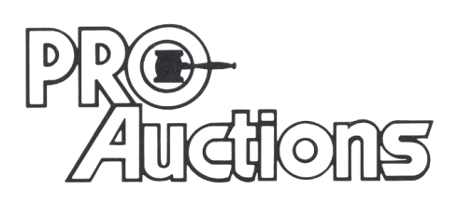Check website for pictures and more information: Proauctionsllc.com
, LLC
RICK GARNHART, AUCTIONEER
IL Lic: 440000901
German Valley, IL
815-238-3044

