FARM LAND AUCTION
FRIDAY FEB. 21 10:30 A.M.!
168.19 ACRES, JoDaviess County, IL

AUCTION SITE: Lena Community Center, 497 Lions Dr., Lena, IL 61048
Location of Property and General Information: Farm is ideally located in Northwestern IL. From Lena, IL take Stagecoach Trail northwest to Nora, IL. East on E. Maier Rd. Farm is located in Section 4,
Nora Township, JoDaviess County, IL.

Highly productive soil; Class A, B, C Soils
Spring 2020 Possession, open lease
Offered as:
Tract 1: 61.25 Acres Farm Land – 91% Tillable, P.I. 118.04
Tract 2: 106.94 Acres Farm Land – 95% Tillable, P.I. 133.35
Tract 1 and Tract 2 Combined: Total 168.19 Acres

MYRNA M. SEURING ESTATE
Kent Seuring, Executor
Representing Attorney: John B. Whiton
Fishburn, Whiton, Thruman LTD 815-235-2511
Details, Maps, Terms & Photos online:
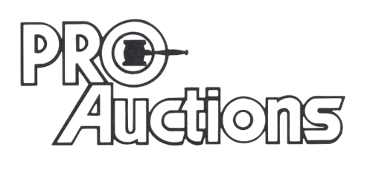Proauctionsllc.com
, LLC
RICK GARNHART, AUCTIONEER
IL Lic: 440000901 German Valley, IL 815-238-3044

