PRIME FARM LAND REAL ESTATE AUCTION
FRIDAY JAN. 31, 2020 10:30 A.M.!
Julene J. Stewart, Owner
155.51 ACRES, 1 Tract – Carroll County, IL
Property Location: Section 20, Shannon Township;
Go East of Shannon, IL on Rt. 72 to Goldmine Rd., south ¼ mile.

Highly Productive Farm Land: 137.8 P.I. Index, all Class A Farm Land.
Hard road frontage.
Possession 2020 crop year, Open Lease
Tax code: 01-06-20-200-003
Tax Amount: $4,994.58

Legal: The North half of the Southeast Quarter and the South Half of the Northeast Quarter of Section 20, in Township 25 North, Range 7 East of the Fourth Principal Meridian.
Auction to be held at: Stephenson County Farm Bureau, 210 W. Spring St., Freeport, IL
For more information call Auctioneer
Heather McPherson of McPherson Law Offices, Freeport, IL 815-235-4411
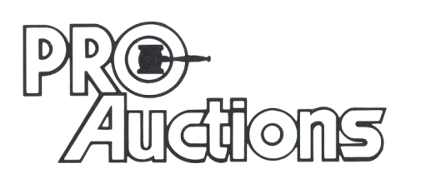Visit Website for Maps, Terms and Pictures: Proauctionsllc.com
, LLC

RICK GARNHART, AUCTIONEER
IL Lic: 440000901 German Valley, IL 815-238-3044

