HUGE TOY AUCTION
SUNDAY FEB 2 10:00 A.M.!
Jane Addams Community Center
430 Washington St., Cedarville, IL 61013
120+ ARCADE TOYS (from private NW IL Collection): Furniture, Daisy Stove, Toledo Scale, Mack: Dump Truck, Stake Truck, Ice Truck (complete), Chester Gump in Pony Cart, 50+ Penny Toys, Corn Planter, Corn Harvestor, Sm Red Stake Truck, Red Bus, Racer, Model A Coupe, Ford Tudar, Red Wrecker, Horse Drawn Dump Wagon, #2 yellow Cab, Car Transport w/ cars, Greyhound Coach, Chevrolet Superior Sedan, McDeering Tractor, Panama Dump Wagon, Literature, Ice Shaver, Ice Pick, Ash Tray, Possum Bank, Andy Gump Bank on stump, Water Hand Pump, Other assort. Animal CI Banks, Bathroom & Bedrm. Sets, Cannon, Circus Wagon, 15 Road & Construction Signs; Windup Cat Crawler
Al Hune Book 1990; plus more.
STRUCTO-OLIVER-CONSTRUCTION-MISC-OTHER: Kilgore Wheel Barrow; Structo: Cattle Hauler, Car Hauler, Van Lines, Grader, Fire Truck, Dump Truck, Ready Mix w/ box; Freidag Flag Holder;
Oliver Show Tractors: 1950T, S-77D, S-77 w/ 82 mower, 77 LP w/ Firestone, 3-S.99GM Red Wheel; Massey 98 w/ GM; 15 Assort. MH, MM, Case, Cockshutt, Silver King; 10+ Kelly Tire Truck Collection;1933 Century Progress Radio Flyer Wagon; Slik Oliver Combine w/ box; Mankato 88 Tractor; 1930 Marx Typewriter; Early JD 14A Combine; Rawleigh Tins & Bottles; 75 Old Match Box Cars & Trucks w/ boxes; Tonka Toys; Asplundh Tree Truck; Dealer Promo Lund Base Boat; Midge Toys-sample case Rockford; Star Wars Figures; Lawn & Garden Sets; 4’x3’ Case-IL Sign; Assort. Barns & Buildings; Tru Scale Toys; 50+ Assort. 1/16 Tractor & Implements, all NIB; Assort. 1/64 Tractors; 1913 Stephenson County Atlas.
NOTE: LG. AUCTION OF OLD & NEW TOYS. RARE ARCADE & FREEPORT TOYS.
Terms: Cash or check with picture ID. Auction held inside w/ Lunch and Restrooms on site.

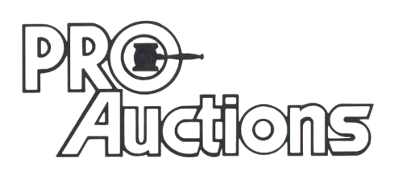 Check website for pictures: Proauctionsllc.com
, LL C
RICK GARNHART, AUCTIONEER
German Valley, IL 815-238-3044
IL Lic: 440000901

