HUGE TOY AUCTION
SUNDAY FEB 23 10:00 A.M.!
Jane Addams Community Center
430 Washington St., Cedarville, IL 61013
Leon & Garnet Obenchain Collection
1st of 5 Auctions to be held for the Obenchain’s - 40 + yrs collecting
500+ FARM TOYS & CONSTRUCTION TOYS: Pedals: IHC 560 & JD 4020 Tractors, JD Pedal Car, Spirit of M.M. Tractor, Rare Coca-Cola Pedal Car & Trailer; Early MF Combine & Tractors; NIB 50+ 4x4 Tractors, all types & colors; MM Tractors; 200+ 1/64 Tractors; True Scale; Nylint Semi & Toys NIB; Steiger 4x4 Tractors; Big Bud 4x4 Tractors: 1/16 th 747, 1/32rd, 1/64; Gold MTX Precision; 1206 IHC Silver Ontario Tractor; Big Farm Combine; Car Carriers; Restoration Tractor Sets; Ford TW15; JD 4020; Wood Barn; JD 2420 w/ old box; JD Bike; 2 JD 6600 Combines; White 4x4 Red Stripe; Coast to Coast Cart; 1/64 Semi Collection; Wood Coaster Wagon; IHC Farm Sets NIB; 7 HO Gauge Train Sets; American Flyer; Arcade; Plus much more to be unpacked!!
Note: 8’x12’ trailer full of toys to be unpacked yet. Don’t miss this 1st Auction! 90% NIB toys.
Terms: Cash or check with picture ID. Auction held inside w/ Lunch and Restrooms on site.

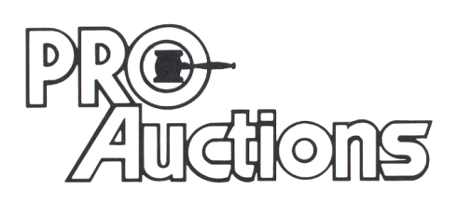 Check website for pictures: Proauctionsllc.com
, LL C
RICK GARNHART, AUCTIONEER
German Valley, IL 815-238-3044
IL Lic: 440000901

