LARGE HOLIDAY FARM TOY AUCTION
SUNDAY NOV. 24 10:00 A.M.!
Jane Addams Community Center
430 Washington St., Cedarville, IL 61013
FROM PRIVATE COLLECTION – 350+ Pcs, 90% NIB: CIH: 370, MX30, Steiger 600,
535 Quad; Oliver: 1950 terra TTT, 77 wf, 880 w/ NI Loader, 1950 Summer Show 2013,1850 Summer Show 2016, 1650 FWA, 66, S-66, 77, S-77, 88, S-88, 995/loader World Pork Expo, 1750, 1955 TTT; MF 1100, 98 w/ Loader, 1150; Ford 5000; MM 445; Challenger MT965, FPS 2008; Cockshutt 1800 wf; Agco RT145; Assort. 1/16 Implements; Assort. NIB 1/64 Toys; 6 True Scale Implements; Structo Trucks; IHC 460, 806; Hubley Ford; Nylint Trucks; Tonka Trucks; Remote Control Boats. JACK ROWLEY ESTATE, ORANGEVILLE, IL-ALL IHC, 25 YR. COLLECTION: IHC MTA, 1206, 756, 856, 560 Gold, 5488, 100 yr, 706, 806, 1456, 1056, 1586, 560,1/8th,4366-4x4, 826 Gold, 1026 Hydro, MX240, 135, 5250, 8950, 5288, 6388-2x2.
OTHER CONSIGNMENTS FROM MIDWEST: 14 Nylint Semi Trucks NIB; 20 Nylint Trucks; Tonka Crane; 10 Freeport Kiwanis Truck Banks; 25+ 1/64 Semi Collection; 250 Truck Banks NIB; 1950’s Buick Pedal Car; 1950’s Garton Pedal Tractor w/ cart; Scooter; Tricycle; Kids Wheelbarrow; Dekalb Seed Corn License Plate holder; Ertl Star Wars Model & other Star Wars items; Ertl Red-yellow Semi w/ Horse Trailer; Hubley Orange Loader; Hubley Toy Gun; Structo red Dump Truck; American Flyer Engine & Tender Car 2; Cast Iron Train; Tin Toys; Power & Sound System in box 2 for Train set; Momad Traction Engine-steam engine 2; Country Farm Ranch and Deluxe Farm Set.
SPECIAL ITEMS: 100+ Barbie Dolls NIB. PLUS MORE BOXES TO UNPACK!
Terms: Cash or check with picture ID. Auction held inside w/ Lunch and Restrooms on site.
Note: Get an early start on Holiday Shopping!

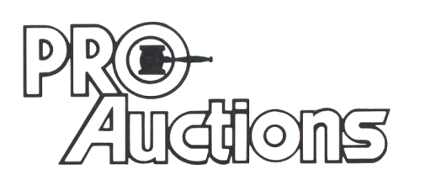 Check website for pictures: Proauctionsllc.com
, LL C
RICK GARNHART, AUCTIONEER
German Valley, IL 815-238-3044
IL Lic: 440000901

