HUGE JOHN DEERE TOY AUCTION
SUN. AUG. 18 10:00 A.M.!
“Gary Rudsinski 45+ yr. Collection”, Marengo, IL
Sale to be held at: Jane Addams Community Center
430 Washington St., Cedarville, IL 61013
Directions: North of Freeport, IL on Hwy. 26. Go to Cedarville. Turn right at Mobil station; go 3 blocks to auction.
Note: Largest collection of J.D. to be sold at auction in Northern IL! Many are unusual toys, 95% NIB! Farm Toys from late 1960’s to present.
900-1,000 PCS J.D. TOYS & COLLECTIBLES (abbreviated list): 1960’s Ice Cream Box w/ 12A Combine, Crawler, 70 Tractor, Mtd. Picker; 70 w/ SN Picker; Titan II & 9600 Combine & Prestige; Yoder 320, 720; Threshing Machine; Early Corn Planter; Grain Drill; JD 9510, 9500, 9200 4wd Combine; Every Precision Series Toy J.D. ever made w/ some duplication incl. 5010, 720 w/ loader, Waterloo Boy, 4440,70, 8020, 3010, 4020, 214, Wagon, 6030; 4-4020 w/ 237 Picker, JDA w/ cultivator; 2 cyl. Club JD; 9420T; Assort. Crawlers; 7520 2/ cab & air; Many, many show Tractors & Collector Tractors; 8870 4wd; Patio Set 140; Hay loaders; 2266-U-32; Horse drawn custom Toys; Semi Trucks; Construction Toys; Historical Sets; 20+ Key Series Tractors; 2 JD Train Sets, HO; Lafayette 730; Dinnerware; Cookie Jar; Radio Control Tractor; Plus 100 more NIB Toys related to John Deere! OTHER: Buddy L Fire truck; IHC 1566, 100 hydro, 1066, 3 SMTA, etc; AC D-17 w/ Picker; 4 IHC 1256;Toy Farmer; Oliver 770 w/ loader; Plastic IHC Crawler; Sev. Early Gleaner Combines; MH Combine; Arcade Wagon & Horses; Fox 3000 Chopper; 4-IHC 1256 Show Tractors; Iowa Pork Expo-Oliver 770 w/ loader.
Terms: Cash or check w/ picture ID. Absentee bidding available. Contact Auctioneer.
Lunch, Restrooms, Seating available. Check website for many pictures: Proauctionsllc.com
Extra Note: Very large auction. Plan to spend the whole day!

RICK GARNHART, AUCTIONEER
German Valley, IL 815-238-3044
IL Lic: 440000901

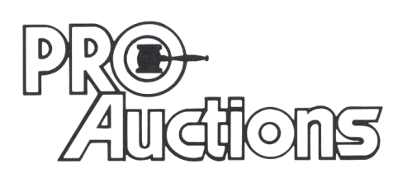
, LLC

