HUGE FARM TOY AUCTION
SUNDAY OCT 27 10:00 A.M.!
Jane Addams Community Center
430 Washington St., Cedarville, IL 61013
500-600+ TOYS
KEN SIGAFUS-COMPLETE COLLECTION (95% NIB) FROM FREEPORT, IL: JD Precision 70, 630, Wagon; Ind. JD 5020, 730, Backhoe; 1/8 JD 4020; JD Silver 60, 9330; Kinzie Big Blue; 1/8 IHC 1206; Big Bud 16V-747; Ford FW-60; IHC TD25, 560 Pay Loader; Pedal Tractors: Farmall M Demonstrator, White 6510 wf; JD 8530 w/ duals; 50+ Nylint Trucks; Structo: Cement Mixer, Sanitation Truck; Orange Cattle Truck; Napa 25th Anniv. Semi; Smith Miller; 50+ Semi Trucks-1/16; Freeport Toy Company (Florence Station); Hess Collection; Hot Wheels; Tin Windup; Midge Toys, Rockford, IL; Keystone; Plus other assort. Trucks.
JUNIOR RABE ESTATE (90% NIB), ORANGEVILLE, IL: JD Little Books; JD Tricycle, Wagon; IHC 460, 3 Spreaders; Reuhl Combine; Structo Trucks; 2 Plastic Farmall M’s; Arcade: Wheel Barrow, Well Pump, Red Stake Truck; License Plates: 1930, 40, 50’s; Precision JD: 4020, FFA, 720, B; 720 w/ loader, Oliver S77-88, Avery A, AC D-17, IHC SMTA; MM 4 star; IH 2+2, 460 w/ loader, 504 w/ 4 RC, 1206, 300 LP; Freeport Home Town Series Banks; Plus more.
ALLEN WURSTER COLLECTION, ELIZABETH, IL – 30+ TRACTORS: 2 AC WC Precision; AC 6080; #6 Green; Fordson; Case DC3; IHC 300, 4166, 82 Combine; JD 520, 2010, GW, 44 Spreader; Assort. Farm Implements; Plus more.
Terms: Cash or check with picture ID. Auction held inside w/ Lunch and Restrooms on site.

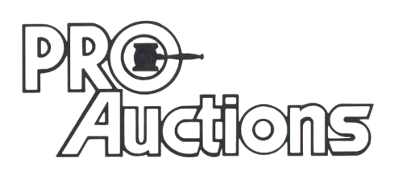 Check new website for pictures: Proauctionsllc.com
, LL C
RICK GARNHART, AUCTIONEER
German Valley, IL 815-238-3044
IL Lic: 440000901

