LARGE TOY AUCTION
SUNDAY JUNE 30 10:00 A.M.!
Jane Addams Community Center
430 Washington St., Cedarville, IL 61013
Location: North of Freeport, IL on Rt. 26 to the Mobil Station in Cedarville. Go west 3 blocks.
Larry Dyson Collection, Orangeville, IL – 35 yr. collection
60+ OLIVER FARM TOYS INCL: S99, 66, 1355, 770, 880, 660, S66, 1950T, 2655, 1850, 880LP, 770, 880 mist green, 1555, Franklin Mint S99, S88 Freeport Show 2012, 880 Ohio Show, 88 Crossroads, 1/64 Semi Truck, 2050 Resin Puller, Forreston Toy Shows: S77, 1950, 1750, 1800 w/ loader, Assort. Implements, Literature, Banks, Airplane, other misc. Oliver items; 200+ Hotwheels, all NIB; 300-400+ Coca-Cola Toys; Ernhardt Items; Construction Toys; 150+ Banks & Trucks; Match Box Set-2,000-3,000 NIB; Western Items: Toys & Collectibles; Adver. Yard Sticks.
Note: Unusual opportunity to purchase rare Oliver Farm Toys & Coca-Cola items. Something exciting for everyone. Don’t miss!!
Terms: Cash or check with picture ID. Lunch, Restrooms, Seating available.
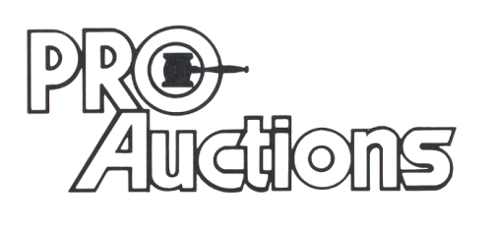 Check website for pictures: Proauctionsllc.com
, LL C
RICK GARNHART, AUCTIONEER
German Valley, IL 815-238-3044
IL Lic: 440000901

