HUGE TOY AUCTION
SUNDAY MARCH 31 10:00 A.M.!
Jane Addams Community Center
430 Washington St., Cedarville, IL 61013
Location: North of Freeport, IL on Rt. 26 to the Mobil Station in Cedarville. Go west 3 blocks.
FARM TOYS – BEER SIGNS – MUSCLE CARS – ADVERTISING – BARBIE DOLLS:
70+ American Muscle Cars, NIB; Older bubble Packs, Hotwheels; Revell Model Car Kits;
35+ Older Structo Trucks & Semis (1960’s); All NIB: 25 Barbie Dolls, Highway 61 Trucks, Tonka Trucks, 1960’s; 15+ Nylint Semi Trucks (1970s) incl: BP, McNess, Nappa, Woods, Mayflower, Pioneer, 7-up, others, 1/64 Gleaner, Challenger, NH Sets, 1/18 Mopar Club GTX, Dodge Charger, Dodge Challenger, Plymouth Duster, Dodge Bengal Charger; Nylint Steel Classics; CIH MX270 Radio Control Tractor; 50+ Older Farm Toys & Implements incl. Wooden Barn, Assort. 1/64 Farm Toys; 1/16 Farmall, MM, Oliver, all NIB; Feed & Seed Advert. Items; JD 1 gal. Oil Can; BEER SIGNS – with lights: Olympic, Busch, Schlitz; Budweiser, Miller; With clock:
2 Hamms, Clydsdale; Neon: Herman Joseph Neon, Olde English, Budweiser Horse,
4’ Budweiser Lite.
Note: Unusual assort. Of hard to find Beer Signs. Also Structo, Nylint Toys w/ Farm Toys offered is quite the opportunity!
Terms: Cash or check with picture ID. Lunch, Restrooms, Seating available.
Check new website for pictures: Proauctionsllc.com
RICK GARNHART, AUCTIONEER
German Valley, IL 815-238-3044
IL Lic: 440000901

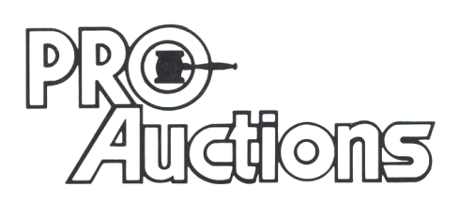
, LL C

