HUGE FARM TOY AUCTION
SUNDAY FEB. 24 10:00 A.M.!
Jane Addams Community Center
430 Washington St., Cedarville, IL 61013

Location: North of Freeport, IL on Rt. 26 to the Mobil Station in Cedarville. Go west 3 blocks.
Tom & Dee Bruecks Toy Collection, NIB – 150+ IHC Farm Tractors & Implements incl: Gold Demo-1456, 826, 1026; 1468 & 1568, both V-8; Collector Tractors: 1566, 1456, 966, 806, 856, 826, Hydro 100; Winter Convention 856; 20+ Toy Show Tractors; T-340; F-20,H,M, WD9, SC, 230, 140, SAV, TTT IHCA, 3 Cubs; 7 National FFA Tractors; 560 Pedal; SM Signature FPS Pedal; Windmills, Pens, Pencils. Other: Cletrac HG; JD Gas Engines; JD 420 Crawler;
JD A, 70, B; JD 4020 w/ 237 Picker; Precision JD; Standi Toys; 20+ Tru Scale.
FORRESTON FFA TOY SHOW TRACTORS: JD MT; Olivers: S77 NF & WF, S88 NF & WF, 770 Checkerboard, 1950 WF Detroit.
CONSIGNMENTS FROM ALLEN WORSTER, Elizabeth, IL and others from Monroe & Monticello: 18 assort. Tractors 1/16, NIB: Ford; IHC; JD; DA; Cockshutt; Assort. Implements; 45+ Pc. JD- 1/16, 1/64 NIB; 28 Pcs. 1/50 CAT Construction Machines, NIB; Assort. Literature; Books. Many boxes yet to unpack.
Note: Very large, high quality Farm & Construction Toys. There will also be many surprises!
Terms: Cash or check with picture ID. Auction held inside w/ Lunch and Restrooms on site.

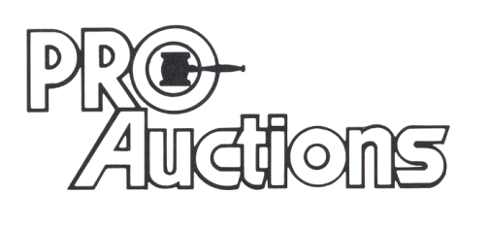 Check new website for pictures: Proauctionsllc.com
, LL C
RICK GARNHART, AUCTIONEER
German Valley, IL 815-238-3044
IL Lic: 440000901

