HUGE FARM TOY AUCTION
SUNDAY JAN. 27 10:00 A.M.!
Jane Addams Community Center
430 Washington St., Cedarville, IL 61013
Location: North of Freeport, IL on Rt. 26 to the Mobil Station in Cedarville. Go west 3 blocks.
40+ Yr. IHC COLLECTION, 70% NIB (Verl Price, McConnell, IL): Max Armstrong WGN IHC M&H; 7250 FWA; 2-1568 & 1456; 7140 FWA; 2-3588, 2+2; 560; 6 Cub Tractors; 1206; Plastic M; 656; 5,000,000-1066; Yoder MTA HC; Gold 1026; Many IHC Implements & Semi Trucks; IHC Tractor & Implement Manuals. PLUS: Early Structo Trucks; 40+ Adv. Yard Sticks; Barbie Cases; Hobbie Horse; Board Games; Assort. Sm. Farm Antiques; Dekalb Seed Wind Vane; Old Seed Corn Books; Plus other misc. Signs & Adv. Items from area.
SMALL COLL. 1/64 & 1/16, 180 PCS: Many rare Farm Toys from Moline area; many early Bubble Pack 1/64 Tractors incl. Case-IH, IH, White, JD, CAT, Ford, Gehl, NH, Vintage Farm Toys, Industrial; PLUS: Match Box; Hot Wheels; Lg. amt. Implements; Structo Car Hauler; Tonka Tractor & Wagon; 1/16 IHC Early Payloader & Backhoe; Plus more.
SMALL COLLECTION, 30+ CARS & TRUCKS (from Rockford, IL): Truck Bank Collection; Revell Engine Model NIB; 2 Franklin mint Cars NIB; plus 2 tables full of misc. toys & adv. Items.
Note: Lots of high quality, rare Toys coming to this auction. Many boxes if IHC tto unpack! Preview 1 hr. prior to sale only. Auction held inside w/ seating available.
Terms: Cash or check with picture ID. Lunch and Restrooms on site.
Check website for pictures and more information:
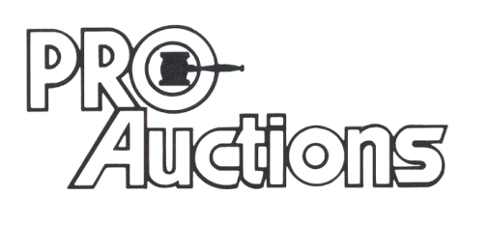 Check new website for pictures: Proauctionsllc.com
, LL C
RICK GARNHART, AUCTIONEER
German Valley, IL 815-238-3044
IL Lic: 440000901

