TERMS OF SALE FOR: Don Shoemaker Estate

AS IS Property is being sold in AS-IS Condition with no warranties expressed or implied. Buyer is advised to make a thorough inspection.

DEPOSIT Earnest money deposit of 10% day of sale of last bid on each parcel. This
deposit is NON REFUNDABLE and will be applied to the purchase price at closing.

CLOSING Within 30 days of auction day.

POSSESSION At Closing.

LEASE Open lease 2019

CONTINGENCY There are no contingencies including those for inspections or financing.

CONTRACT Successful bidder will be required to enter into a written real estate purchase
agreement. The proposed agreement is available for buyers to review prior to the start of the auction.

ANNOUNCEMENTS All announcements made on day of sale supersedes all other prior written or verbal
announcements.

RESERVE Trustee reserves the right to reject all bids.

EVIDENCE OF TITLE Trustee will provide merchantable title in the form of a title insurance commitment and
a warranty deed (or equivalent).

REAL ESTATE TAXES SELLER to pay 2018 Real Estate taxes payable in 2019 by giving the BUYER a credit at
closing.

SURVEY No survey.

MINERAL RIGHTS All mineral rights owned by SELLER, if any, will be transferred to BUYER.

BUYER’S PREMIUM No buyers’ premium on this sale.

Disclaimer: The information provided is taken from sources believed to be accurate and reliable. However, no liability is assumed for errors or omissions. There are no warranties, expressed or implied. Buyers are advised to conduct their own inspection. The Attorneys and Auctioneer conducting the sale are exclusively representing the seller.
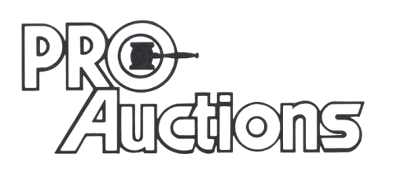
, LLC

RICK GARNHART, AUCTIONEER
IL Lic: 440000901 WI Lic: 2844-52
German Valley, IL 815-238-3044

