FARM LAND REAL ESTATE AUCTION
SAT. NOV. 17 10:00 A.M.
Don Shoemaker Estate – Dakota, IL
Location: Corner E. Cedarville Rd. & N. Fawver Rd.
Sale held at: Stephenson County Farm Bureau, 210 W. Spring St., Freeport, IL
139.11 Acres of Stephenson Co. Farmland
Highly Productive w/ 135.49 Acres Tillable Cropland – 96% M.O.L.
125 PI – Corn/Bean Rotation; One lg. Field w/ water way,
Class A, B with some Class C Soil; Hard Road frontage, ½ mile; H.E.L. Conservation System applied; Open Lease
Dakota School Dist. & Dakota Township
Sells subject to Executor’s confirmation.
Judd Thruman, Fishburn Whiton Thruman, Attorneys at Law for Estate, Freeport, IL 815-235-2511
For further information and terms, call Auctioneer.
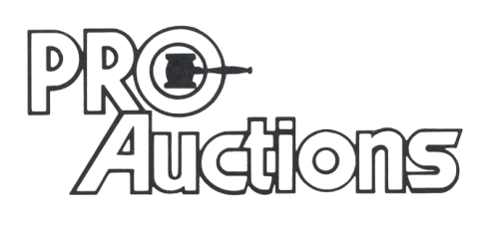
, LLC
New Website: proauctionsllc.com
RICK GARNHART, AUCTIONEER
German Valley, IL 815-238-3044
IL Lic: 440000901 WI Lic: 2844-52

