HUGE FARM TOY AUCTION
SUNDAY OCT. 28 10:00 A.M.
Jane Addams Community Center
430 Washington St., Cedarville, IL
Location: North of Freeport, IL on Rt. 26 to the Mobil Station in Cedarville. Go west 3 blocks.

600+ Pcs. From private collection, Forreston, IL: JD Toys incl. 1/16, 1/64, 1/32-Precision; Hi-Crop; Combines; 4 W. drive; 2 W. drive Tractors; Implements; Lawn & Garden. Deutz-AC: 7040 Farm Set, no box; L& Garden; Implements; Tractors; Local Adver. Items. IHC-CASE IH-Case: Tractors; Combines; Implements, etc. New Holland –New Idea: Tractors; Combines, etc. Ford – MH: Tractors. Oliver: 3 Rare Forreston FFA Show Tractors NIB; Misc. Items: Lots local adver; Rare Buddy L Camper Truck; Belt Buckles; Show Patches & Buttons; Tractor Books; Literature; Rare Franklin Mint Tractors & Cars; 35+ Ertyl Barn Sets NIB (Farm Country); Great Plains Drill; Schwans Ice Cream Truck; Nylint Trucks; Peter Built Trucks; NH Operator’s Videos; 4 Danbury JD Doll Collection.
Special Items: Hesston Clothing from Burma Sales, Forreston, IL; Gronewold Imp. Items; Old Sale Tickets from Baileyville & Forreston area; 600+ Hat Collection from area (seed corn, fert, tractors, farm related); WG Byers, Shannon, IL –IHC Coveralls.
Note: This toy auction is a complete 40+ year collection from Forreston, IL area! Many hard to find toys & adver. pcs. Boxes full to unpack for sale. Preview 1 hr. prior to sale only. Auction held inside w/ seating available.
Terms: Cash or check with picture ID. Lunch and Restrooms on site.
Check website for pictures and more information:
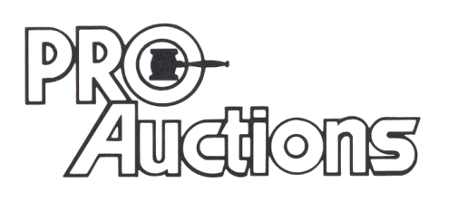 Check new website for pictures: Proauctionsllc.com
, LLC

RICK GARNHART, AUCTIONEER
IL Lic: 440000901 WI Lic: 2844-52
German Valley, IL 815-238-3044

