SHOP EQUIPMENT AUCTION
SAT. SEPT. 15 10:00 A.M.
“Seward Garage” Duane Harms owner
307 W. Soper, Winnebago, IL 815-335-2854
HEAVY DUTY TRUCK, TRACTOR, & AUTO REPAIR SHOP: Craftsman Ind. D.E. Grinder w/ stand; Zip Parts Washer; Gear Pullers; ¾” Socket Sets; Tractor Splitter Stands; Truck Axle Nut Sockets; Drills & Taps; Neiko 1” Impact; Metric ¾” Impact; Jack Stands; Red Arrow 20T. Press; 100+ Shop & I.T. Books/Repair; 2 hp Port. Air Compressor; Enco ¾” Steel Drill Press; 3 Welder Benches; Blackhawk 750# Trans Jack; Welder Bench w/ vise; Eng. Cylinder Hone & Reamers; 2 Air Dye Grinders; 2-20T Bottle Jacks; Chop Saw; Air Power Hack Saw; 8 Dr. Lawson Bolt Bin; 3-Parts Book Racks; Nuts, Bolts, Pipe Fittings, etc; Axle Puller; JD 2 cyl. Ring Puller; Battery Cable Machine; 50 yr. old Bolt Bin-Pec Hardware; G&D Compression Tester; Ford Diesel Tools; Tap & Dye Sets, metric & USA; Impact Driver; Port. Battery Booster; 2 DeWalt Inspection Cameras; DeWalt ¼” Drill; Echo Specialty Tools; 3 Valve Grind Machines; XL Set Gear Wrenches; Blackhawk 750 Eng. Stand; Ex-Cel Cherry Picker w/ ext; Eng. Stand; 2-3T. Floor Jacks; Port. Cherry Picker; OTC Sleeve Puller, wet & dry; Mac Fuel Inj. Tester; Snap-on Scope Tester; 220 Ext. Cords; B&D Valve Tools; Snap-on Air Chisels; Blue Point ½” Impact; 3 Air Bumper Jacks; Coleman 6.5 ½ hp Upright Air Compressor; Mac Vise Grips; 2 Starter-Generator Lathe Tools; 6-12-24 Volt Charger; 100+ Assort. Hand Tools; Handy Power Washer; 2 Craftsman R.A. Tool Chests; Air Hose Reel; Elec. Sheet Metal Nibbler; Cylinder Bore Gauges; Steel Saw Horses; Jackson Garden Tractor for parts; 2-Hahn Rider Tractor for parts; 1966 - 305 Honda Bike for parts; 3-4 wagons full of Shop Tools, Equipment, Oils, etc; Many Special Tools for Shop Work.
Terms: Cash or check w/ picture ID. Lunch Stand on grounds
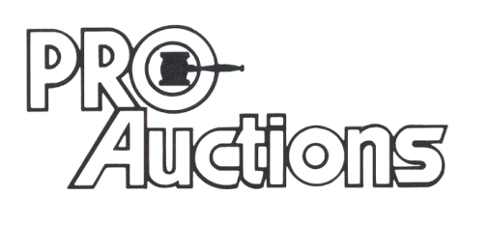
, LLC
New Website: proauctionsllc.com
RICK GARNHART, AUCTIONEER
German Valley, IL 815-238-3044
IL Lic: 440000901 WI Lic: 2844-52

