LARGE ANTIQUE AUCTION
SAT. JUNE 23 (Storm Date: June 24) 10:00 A.M.!
Kevin & Lisa Hunziker
3874 S. Rock City Rd., Ridott, IL (815-990-3462)
Location: East of Freeport, IL to Ridott Corners, 1 ¾ mi. south of US 20 on Rock City Rd. to farm.
Note: 30+ yr. Family Collection of Antiques. This auction is loaded w/ high quality, many rare items. Kevin & Lisa have decided to down size their collection. Put this date on your calendar!
FURNITURE-GLASS-TOYS: 1930 Voss Flo-To Copper Wash Machine; Freeport Wood Manse Pump; 6 Pressed Back Leather Seat Chairs; Pressed Back Oak Platform Rocker; Oak Pressed Office Chair; Walnut Settee; Lovell Wringer; 20+ Crocks & Jug; Oak Cottage Organ; Curved glass China Hutch; Wicker Items; Bentwood Chairs; 6 armed Tavern Chairs; Spool Bed; 1900’s Walnut Victorian Bedrm. Set incl. marble top Dresser, Commode, Gentlemen’s 7 D. Chest; 1942 Walnut Bedrm. Set w/ 2 Chest Drawers; Oak Secretary, drop front; Oak Gentlemen’s Dresser; Assort oval Picture Frames; Vintage Clothes; Arcade Grinder; Milk Bottles; Silver Plate; 1930’s Kitchen Cupboard w/ jars & flour bin; 6 Bowl & Pitcher Sets; Child’s Tea Set; Pens & Pencils; 15 assort. Kerosene & Elec. Lamps (some very old); 1900’s Wood Wall Clock, wooden works; Assort. Mantle Clocks; Tin Bracket Lamps; Double Globe Lamps; Stover Freeport Bracket Lamp; Walnut Sewing Rocker; Marble top Coffee Table; Walnut fainting Couch; Victorian Slipper Chair; Oak Wash Stand w/ D. Towel Bar; Child’s Wash Stand; Baby Buggy; Walnut Commode, 2 d; 5 Carved Sea Trunks; 1970 Postscript Steph. Co. History; Walnut Settee; Walnut Drop Leaf Table; Organ Stools; Victorian Carved Crest Chair; 2 old Floor Radios; Wicker Dress Form; Granite wear; Cheese Boxes from Sunny Hill Cheese Factory; Wash Tubs; Crockery Bowls; Old Hardware; 7-8’ Banquet Tables; Old Pressmn Wood Bowling Game; Lionel Train Set; Plus much more Misc. Items
(3 wagons full).
FARM RELATED – PRIMITIVES-ADVER-MISC: 1950 Gulf Gas Pump (No Nox Ethyl); Wagon Seat; Oil related items; 1 Horse Cutter, restored by Frank Oschner; Old Harness & Collars; Harness Hooks; Wood Wagon Jack; Tongue, single tree; Other Horse Items; 40’ Wood Ex. Ladder; Corn Dryers; Yard Decorations; Steel Wheels; Wood 50 gal. Barrels; Bee Hive; Fair Bank Platform Scale; Scoup Boards; 2-30” Oval Enamel Coca Cola Signs, double sided; Pleasant Prairie Yearbook; Brass Family items from German Valley; McNess & Rawleigh Items; 1970 Postscript Steph. Co. History; McVille Ohio Sword; Lots of sm. Freeport, Ridott, Forreston, German Vy, Adeline Adver. Items.
Terms: Cash or check w/ picture ID. Lunch Stand & Porta-Pot available
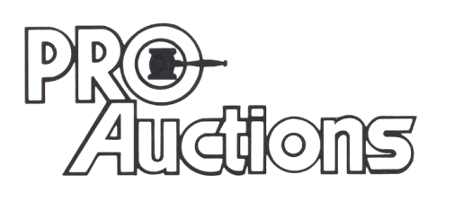
, LLC
New Website: proauctionsllc.com
RICK GARNHART, AUCTIONEER
IL Lic: 440000901 WI Lic: 2844-52
German Valley, IL 815-238-3044

